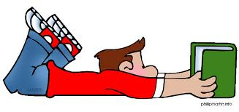
Tips for helping your child become a better reader

When you read with your child, be careful not to correct their errors, but rather guide you child into self-monitoring. If you child reads a word incorrectly and does not pause or re-read to self-correct, here are some helpful prompts to use.

- Did that make sense?
- Did that look right?
- Did it sound right?
- Try that again and think what would make sense.
- Try that again and think what would look right.
- Try that again and think what would sound right.
- Do you know something that would make sense and starts/ends like that?
- What do you know that might help?
- Read from the beginning and try that again.

Readers should use 3 different cueing systems when reading an unknown word. Try to encourage your child to use clues from all three areas.

